FAILURE STORIES!

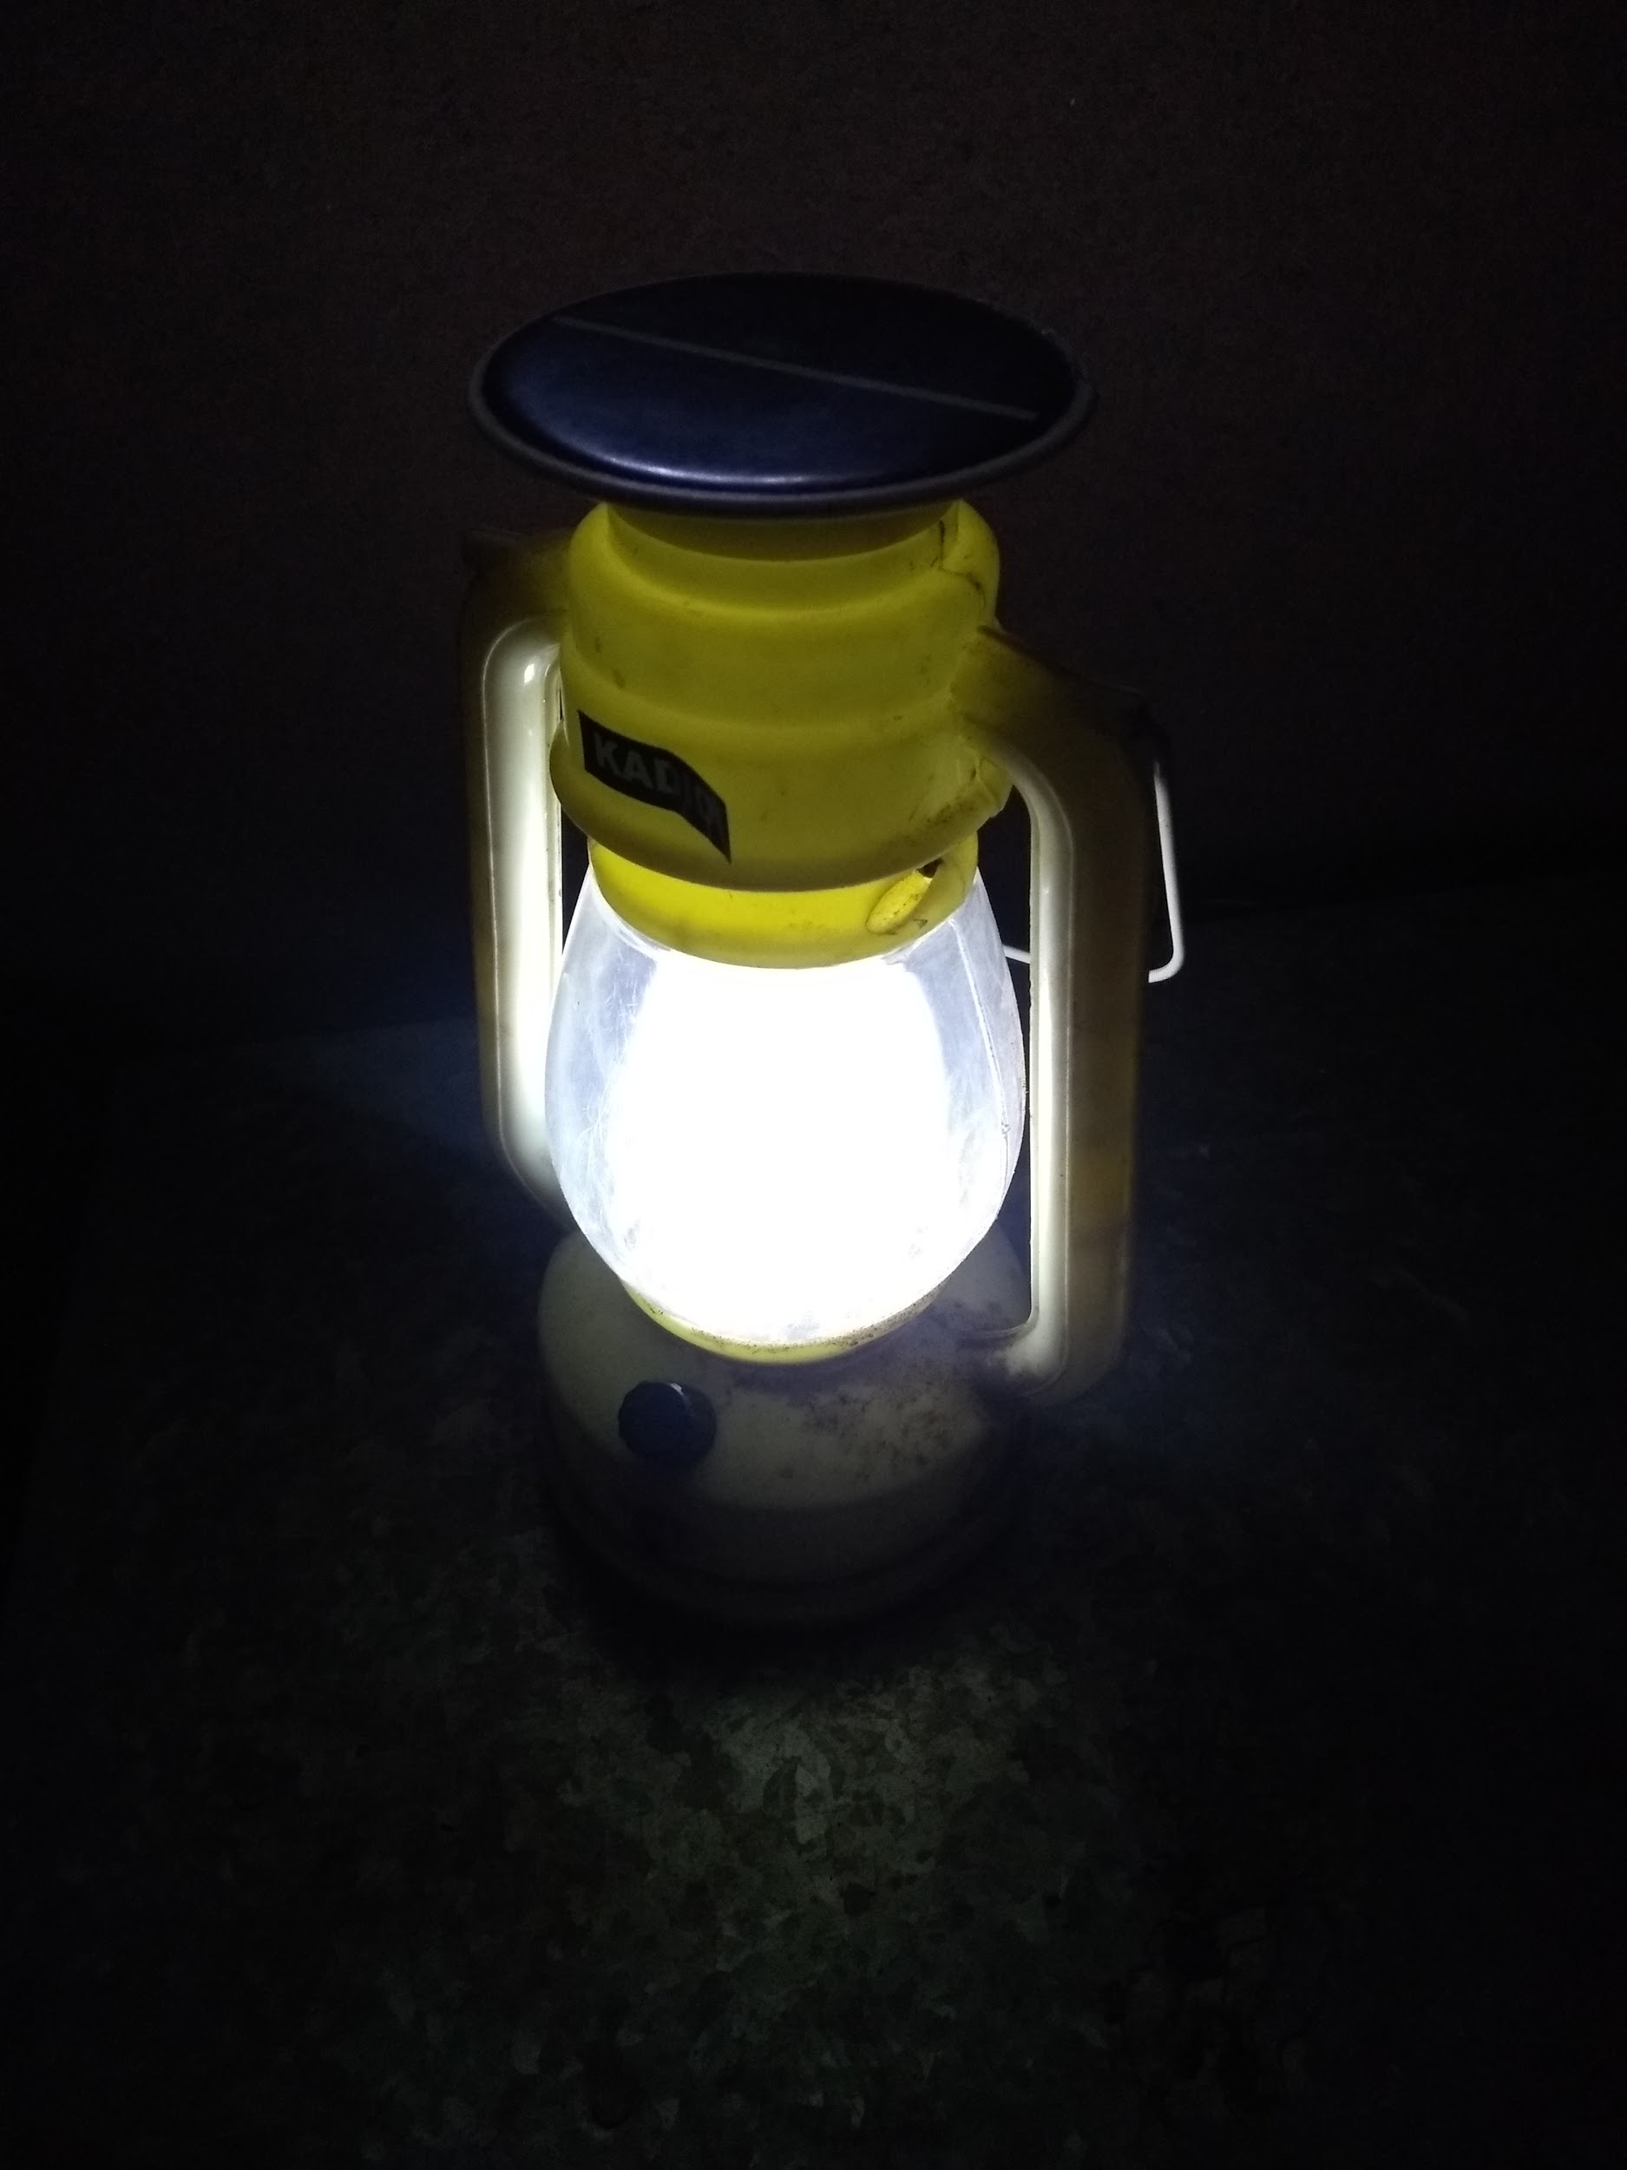

At the age of ten, I wanted to be the God - you know the supreme powerful lord of the universe, who gets a house up in the sky, unlimited amenities with some of my favourite eatables as offerings - and of course, the power to control my one crazy not so little family!

In those days, I was doing academically well. I topped my class, cracked inter-school competitions and delivered good oratory experiences - I was the golden child at my high school. I knew what success felt like. Failure wasn't a concept I was taught at school. Because hey, why could such a bright child ever fail? What was the need, right?

Well, I did. I failed. Once in midterms, probably in some of the class tests - I was consistently a poor performer in my higher secondary. But then, I just failed and yet, didn't know how to fail! I won't go into the specifications of how it felt like but I realised what failure looked like if I couldn't feel it in my nerves.

I was epic. I still am. I take unexpected routes to cross over the failures and probably, I'll have some great stories for your grandkids if you choose to have my company in your old age. (Hold on - this could be a great pick up line in case I decide to hit on someone! Damn, 😁😂) Over years of failures, I have realised how important it is to know how to fail effectively. And something so much crucial is just ignored randomly. We know there's a prize for success but what about failures? Yeah, we fail, we all do. Somewhere. Sometimes. What after that?

It's painfully a small space to write so much about my chronicles with my failures but I'll tell you what I want to be now - the legit copyrighted mascot for FAILURES. I do.

Of course, I want epic successes. But only after effective failures. I may continue on a second part - What? Why? How? All of it.

And as to what happened to my ambitions to be the God? Well... I just grew out of the theistic concept! Damn it.